Computer vision

Programming Assignment 2

1. A) Constant Speed

Curve 1: Circle. To check the correctness, based on whether the normal pointing inwards or outwards the circle should shrink or expand at each Iteration.

After 1 Iteration

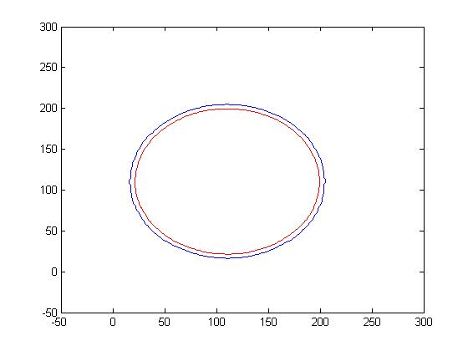  
After 2 Iteration

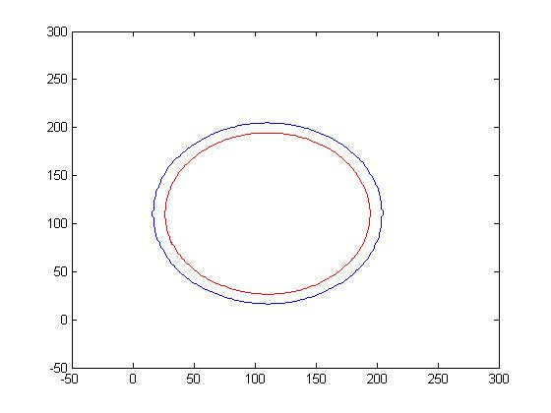

After 3 Iteration

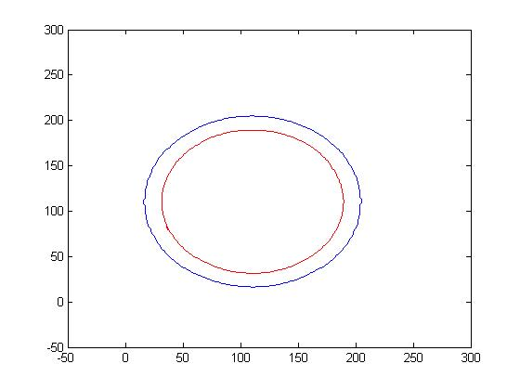

Curve 2: Random curve draw in paint.

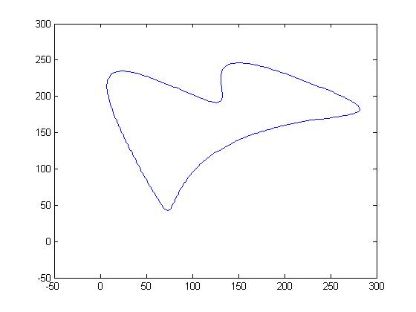

After 1 Iteration

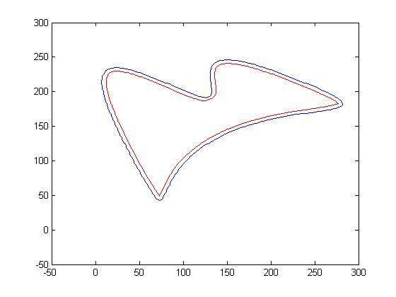

After 2 Iteration

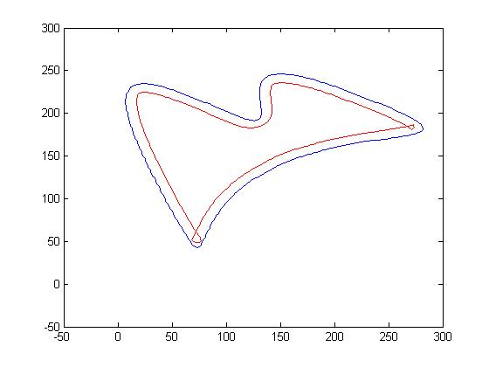

After 3 Iteration

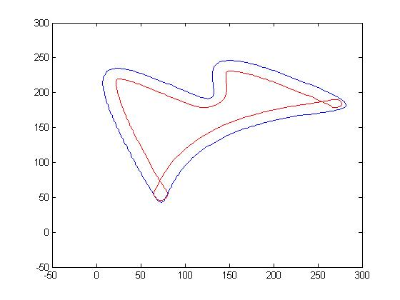

Curve 3: Pacman

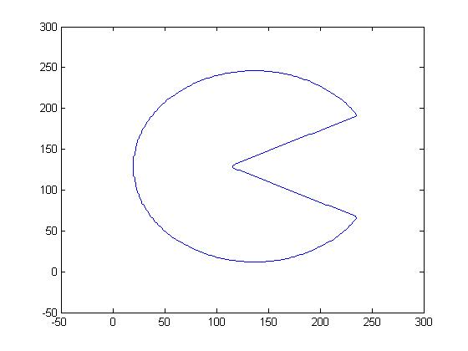

After 1 Iteration

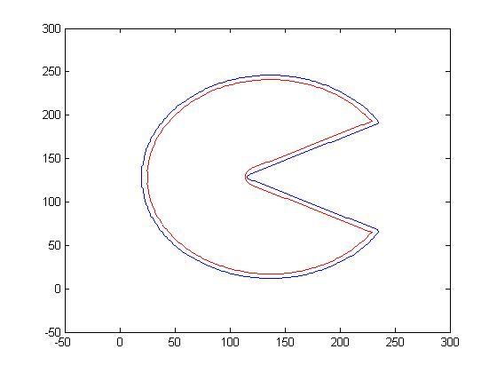

After 2 Iteration

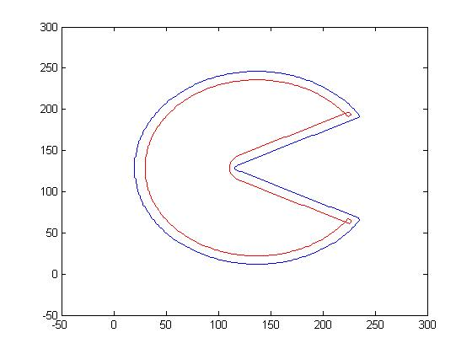

After 3 Iteration

